**Table of contents**

**Chapter 01: Introduction**

* 1. Overview
  2. Why Home Automation?
  3. History of Home Automation
  4. Project Aim and Objective
  5. Motivation
  6. Thesis Outline

**Chapter 02: Literature Review**

2.1 Overview

2.2 Other’s work / existing literature explanation

2.3 Status of Home Automation in terms of global and our country aspect

2.5 Summary

**Chapter 03: System Design plan**

3.1 Overview

3.2 System Architecture

3.2.1 Hardware Architecture (explain with the diagram)

3.2.3 Software Architecture (same / try to explain with a flowchart)

3.3 Summary

**Chapter 04: Methodology and Implementation**

4.1 Overview

4.2 Hardware and Software Requirements

4.3 Implementation / device setup

4.3.1 Hardware

4.3.1.1 Relay

4.3.1.2 Zero Crossing Detector (ZCD)

4.3.1.3 Energy meter

4.3.1.4 Thyristor based Switching units

4.3.1.5 Current / Voltage sensor

4.3.1.6 Microcontroller (Arduino Pro Mini)

4.3.1.7 Building the power supply and interfacing the Relay

4.3.1.8 Measuring the frequency of AC signal by Zero Crossing Detector (ZCD)

4.3.1.9 Serial communication between Microcontroller and Mobile application

4.3.1.10 Powerline communication

4.3.1.11 Remote Connectivity

4.3.2 Software

4.3.2.1 Communication

4.3.2.2 Embedded Programming

4.3.2.2.1 Programming the Microcontroller

4.3.2.3 Web Interface ( how you created it and how it stores data)

4.4 Summary

**Chapter 05: Results and Testing**

5.1 Overview

5.2 Testing the complete design and output / Testing Hardware and Software

5.3 Power consumption

5.4 Simulation

5.5 Summary

**( more things need to be added in this chapter, i.e: what issues been faced while operating the devices, what results came out from there after testing them etc).**

**Chapter 06: Discussion**

6.1 Overview

6.2 Costing / Cost of tools used

6.3 Future work and Discussion

6.4 Limitations of this project / Challenges of Home Automation

6.5 Conclusion

Appendix

Reference

**Chapter 1**

**Introduction**

* 1. **Overview**

In today’s world everything is becoming modernized and almost everything is being controlled electronically and wirelessly. Keeping with the trend, the world at present is seeing increased amounts of automation in homes. Home automation usually signifies increased automation of household appliances through electronic means that allow for things impracticable, overly expensive or simply not possible in recent past decades. Home automation gives us access to control devices in our home from mobile device anywhere in the world. Home automation more accurately describes homes in which nearly everything, such as; lights, fans, appliances, electrical outlets etc are hooked up to a remotely controllable network. However, many techniques used in building automation (such as light and climate control, control of doors and window shutters, security and surveillance systems, etc.) are also used in home automation, additional functions in home automation include the control of multi-media home entertainment systems, automatic plant watering and pet feeding, smart appliances such as; refrigerators, dryers, washers, lighting etc, smart security systems (sensors, monitors, cameras, alarms systems etc) and automatic scenes for dinners.

The home automation system is not as expensive as it used to be but it is still quite costly and for that it has not been extensively implemented in a developing country like ours. Hence we took on task of making a project which would involve automation of homes at a reasonable price with parts that are available within our country. Our IoT project focuses on building a wireless home automation system to which users can get connected remotely and can access and control the appliances of their home through the internet. The users can also be able to see the status of their appliances on their phones , for example, whether a light is switched ‘on’ or ‘off’, by using this wifi connected microcontroller managed system and be notified.

In this chapter we are going to explain, why home automation is needed, history of home automation, our project aim and objectives and it’s benefits and our motivation for doing this project.

* 1. **Why Home Automation?**

The concept of the “Internet of Things” has tied closely with the popularization of home automation. IoT based home automation refers to the application of computer and information technology for control of home appliances easily from remote places. This IoT based home automation system allows us to program devices on the network and to remotely connect and monitor real object (things) through the internet. Home automation can provide increased quality of life for the elderly or disabled persons who need caregivers and it also can offer the comfort and security for the private home’s residents. Basically, Home Automation can make our life a lot easier and safer.

* 1. **History of Home Automation**

The idea of Home Automation has been around for a long time. For decades, science fiction has explored the idea of home automation. This timeline below explains from the early inventions of home automation leading up to the smart homes we know today. [1]

**1785 – The invention of remote control:** Nikola Tesla invented the first remote control which could control a toy boat.

**1901 – 1920 – The invention of Home appliances:** The 20th century started with the invention of the first home appliances. The first engine-powered vacuum cleaner was invented in 1901. Then a more practical electricity-powered vacuum was invented in 1907. Throughout the two decades refrigerators were invented as well as clothes dryers, washing machines, toasters and so much more.

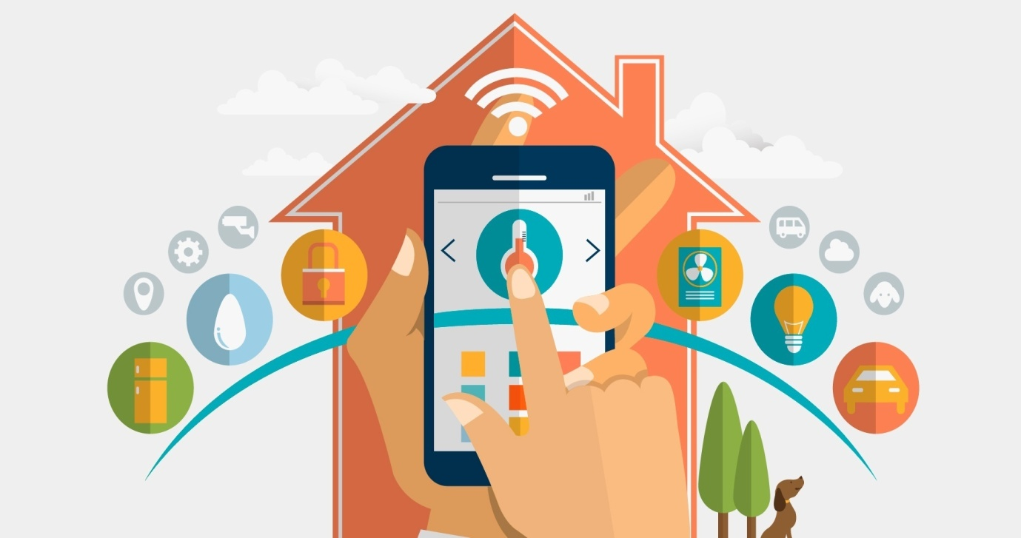

**1966 – 1967 -** **ECHO IV and the Kitchen Computer** –  The ECHO-IV was the first smart device which could compute shopping list, control the home’s temperature and turn appliances on and off. The kitchen computer was invented a year later which could store number of recipes. But unfortunately these two products were never commercially sold.

There were many more advances after that but things moved slowly. The idea of smart home finally came around in 1984.

**1998 – Early 2000s:** **Smart Homes** – In the early 2000s, different technologies began to emerge. Smart homes, or home automation, began to increase in popularity in the early 2000s. Smart homes suddenly became a more affordable option and became a viable technology for consumers. Domestic technologies, home networking, and other gadgets began to appear later in market

**Today’s Smart Homes** - Today’s smart homes are more about security, comfort and

convenience. Today’s smart homes are sustainable, and they help to ensure that our homes

aren’t expending unnecessary energy. They also help alert us to intruders (whether we’re

home or not). Current trends in home automation include remote mobile control, automated

lights, automated thermostat adjustment, scheduling appliances, mobile/email/text

notifications, remote video surveillance and many more. Current home automation system

provides mobile apps for users to control home appliances remotely through internet. In

addition, current home automation system provides the facility for users to control any load

or home device remotely using internet network over the Cloud platform. It provides open API for smart home device to integrate with cloud platform easily.

.

* 1. **Project Aim and Objective**

As technology is advancing so houses are getting smarter day by day. Modern houses are gradually shifting from conventional switches to centralized control system which involves remote control switches. The conventional switches located in different parts of the house makes it difficult for the users to go near them and operate. Especially, it becomes more difficult for the elderly or physically handicapped people to do so. In this aspect, our proposed system can help people to solve these problems and using this system user can be greatly benefitted.

The points below show our project’s aim and objectives:

* Our aim is to build a Home Automation System that will improve comfort, enhance accessibility, minimize operating costs, simplify use of technologies, and promote energy efficiency and convenience.
* We aim to build a system that will enable people who are out of their homes most of the time to monitor their homes in real time from anywhere in the world.
* Using our system, the physically challenged people can also easily control basic appliances through an already available cell phone using an application.
* Our system can also be used in hospitals to manage certain room conditions.

The main objective of this project is to develop a Home Automation System using an Arduino board which can be remotely controlled by any smart phone. Using this system users can control their home appliances that can be connected to a local area network, , via Ethernet or Wi-fi. The GUI application on the cell phone will send ON/OFF commands to the microcontroller (Arduino Nano) at the receiver where loads are connected. By touching the specified location on the GUI, the loads can be turned ON/OFF remotely through this technology.

* 1. **Motivation**

In today’s world, most existing solutions in home automation systems lack certain significant features. For example, most existing systems are not affordable for most users due to high costs and difficult maintenance and some systems provide solutions that are not very useful for household applications. Many tasks are repetitive in nature, such as, turning on or off lights, fans or dimming lights manually etc. These tasks can be accomplished on one button using home automation. Many accidents happen in the home because of poor lighting. Sometimes at home, the lights or fans remain switched on unnecessarily when the residents go outside their home. So home automation products can reduce these power consumption, utility bills and automatically turn off lights and appliances when they are not in use. Using IoT based home automation products, users can check the status of their home appliances while they are away without having to worry about whether their room lights or fans are switched on or off.

As most of the home automation devices are very expensive in the market, many people in our country think that it is only meant for the rich and therefore cannot be afforded in their homes. Also, they lack knowledge in this technology and how they will be benefited from it. Therefore, the motivation behind the development of this system is to let people know about these technologies and make the system as simple as possible for an ordinary person to understand and letting them know of the full benefits the home automation can provide to them. Our motivation is to facilitate the users to automate their home having remote access to the appliances and make their life convenient and comfortable.

* 1. **Thesis Outline**

The entire project is composed of six chapters, each covering a section of the work as summerized below –

* Chapter one gives an introduction to automation as a whole, history of home automation, our project’s aim and objective, it’s benefits and importance and our motivation behind doing this project.
* Chapter two covers an extensive literature review of previous works on home automation system.
* Chapter three is about system design. It includes detail explanation about our hardware architecture and software architecture.
* Chapter four is about methodology and implementation. It provides comprehensive details on both hardware components and communication services used. It also explains the hardware and software requirements for this project.
* Chapter five is regarding results and testing. It gives clear practical details of testing the project design and shows the output results achieved after implementing the design.
* Chapter six is on Discussion. It includes cost analysis about our expenditure made for this project. It also includes the limitations of this project and describes possible future development of this project work.

**References**

**[1]** The historyof smart homes - http://www.afcdud.com/fr/smart-city/422-how-the-history-of-smart-homes.html

[2]